Name: Siddharth Vats

Project: AI Healthcare System

- The project must be developed using appropriate platform for Design and Code.
- Mention names and IDs of all group members on the top of this document.
- There are ___ questions in this assignment. Attempt any one of them, and mention which project you have chosen on the top of this page. In each question, objective to be achieved, expected inputs and expected outputs are mentioned.
- Project submitted after due date will not be evaluated and a score of zero will be awarded.
- Upload a word version of the document.
- The group size should not be more than 3, and the group must be formed from the same section. Inter section groups will not be accepted.
- Plagiarism may lead to award of zero marks.
- If you have doubts about any project, please contact the course instructor.

Table of Contents
1. Introduction
1.1 Purpose
1.2 Scope
1.3 Definitions, Acronyms, and Abbreviations
1.4 References
1.5 Document Overview
2. Overall Description
2.1 Product Perspective
2.2 Product Functions
2.3 User Classes and Characteristics
2.4 Operating Environment
2.5 Design and Implementation Constraints
2.6 Assumptions and Dependencies
3. Functional Requirements
3.1 Symptom Input Module
3.2 Disease Prediction Module
3.3 Doctor Recommendation Module
3.4 Medical Report and Precaution Module
3.5 Optional Patient Registration Module
4. Non-Functional Requirements
4.1 Performance Requirements
4.2 Usability Requirements
4.3 Reliability Requirements
4.4 Security Requirements
4.5 Maintainability and Scalability
4.6 Portability
5. System Architecture
5.1 Architectural Overview
5.2 Data Flow
6. External Interface Requirements
6.1 User Interface
6.2 Software Interface — REST API Specification
6.3 Communication Interface
7. Assumptions and Constraints
8. Future Enhancements
9. ER Diagram
10. Class Diagram
11. Code (ML Model and Backend)
12. Output

1. Introduction

1.1 Purpose
This document presents the Software Requirements Specification (SRS) for the AI-Based Healthcare Diagnosis System. The purpose of this system is to develop an intelligent, web-based healthcare diagnosis platform that assists both medical professionals and patients in identifying probable diseases based on user-provided symptoms and clinical data. It serves as the primary reference document for developers, testers, stakeholders, and evaluators involved in the project.

1.2 Scope
The AI-Based Healthcare Diagnosis System is a web application that accepts patient-reported symptoms and health parameters as input, processes them through a machine learning classification model, and returns medically relevant outputs. The system is intended to serve as a decision-support tool — not a replacement for clinical diagnosis.

Key capabilities of the system include:
- Prediction of the most probable disease category based on user inputs
- Display of confidence scores for the top 3 predicted conditions
- Recommendation of an appropriate medical specialist
- Provision of general precautions associated with the predicted condition

The system is out-of-scope for real-time telemedicine, electronic health record (EHR) integration, and billing or insurance processing in the current version.

1.3 Definitions, Acronyms, and Abbreviations

Term / Acronym | Definition
AI | Artificial Intelligence — simulation of human intelligence processes by machines
ML | Machine Learning — a subset of AI enabling systems to learn patterns from data
API | Application Programming Interface — a protocol for software component interaction
SRS | Software Requirements Specification — this document
UI | User Interface — the visual layer through which users interact with the system
REST | Representational State Transfer — an architectural style for web APIs
JSON | JavaScript Object Notation — a lightweight data-interchange format
Flask | A lightweight Python web framework used for backend development
Vite | A fast frontend build tool used with React

1.4 References
- IEEE Std 830-1998 — IEEE Recommended Practice for Software Requirements Specifications
- scikit-learn Documentation — https://scikit-learn.org
- React Documentation — https://reactjs.org
- Flask Documentation — https://flask.palletsprojects.com

1.5 Document Overview
The remainder of this document is organized as follows: Section 2 provides an overall product description. Section 3 enumerates functional requirements. Section 4 details non-functional requirements. Section 5 describes the system architecture. Section 6 covers external interface requirements. Section 7 states assumptions and constraints. Section 8 outlines future enhancements.

2. Overall Description

2.1 Product Perspective
The AI-Based Healthcare Diagnosis System is a standalone, web-based application developed as part of an academic project. It integrates three primary components:

Component | Technology | Role
Frontend | React (Vite) | User interface for data input and result display
Backend | Python (Flask) | REST API layer for routing and business logic
ML Model | scikit-learn | Disease classification and prediction engine

The system does not interface with any existing hospital management systems or EHR platforms in its current scope. It operates as an independent application accessible via a standard web browser.

2.2 Product Functions
The system provides the following high-level functions:
- Patient symptom input via an interactive web form
- Clinical data entry (age, gender, blood pressure, cholesterol level)
- Disease prediction using a trained ML classification model
- Display of the top 3 probable diseases with associated confidence scores
- Recommendation of an appropriate doctor specialty
- Display of medical precautions for the predicted condition

2.3 User Classes and Characteristics

User Class | Description | Technical Proficiency
Patient (Primary) | Individuals seeking preliminary health assessment based on symptoms | Low to moderate
Doctor (Optional) | Medical professionals reviewing system predictions for advisory purposes | Moderate
Administrator (Future) | System administrators managing datasets and configurations | High

2.4 Operating Environment

Category | Specification
Operating System | Windows 10/11, macOS 11+, Ubuntu 20.04+
Web Browser | Google Chrome 90+, Mozilla Firefox 88+, Microsoft Edge 90+
Backend Runtime | Python 3.8 or higher
Frontend Framework | React 18.x with Vite build tool
Backend Framework | Flask 2.x
ML Libraries | scikit-learn, NumPy, pandas
Network | Internet connection required for deployment; localhost for development

2.5 Design and Implementation Constraints
- The ML model's accuracy is constrained by the size and quality of the training dataset
- The system does not provide legally binding medical diagnoses
- No persistent storage of patient data is implemented in the current version
- The application is intended for educational and demonstration purposes only

2.6 Assumptions and Dependencies
- Users have access to a modern web browser with JavaScript enabled
- The Flask backend and ML model are deployed and accessible
- The training dataset accurately represents the general population's symptom-disease relationships
- Symptom descriptions provided by users are accurate and truthful

3. Functional Requirements

3.1 Symptom Input Module

3.1.1 Description
The system shall provide an interactive user interface allowing patients to specify their symptoms and provide basic health parameters.

3.1.2 Requirements

Req. ID | Requirement Description | Priority
FR-01 | The system shall display a list of symptoms with Yes/No toggle inputs | High
FR-02 | The system shall allow entry of patient age (integer, 1–120) | High
FR-03 | The system shall allow selection of gender (Male/Female/Other) | High
FR-04 | The system shall allow entry of blood pressure level (Low/Normal/High) | High
FR-05 | The system shall allow entry of cholesterol level (Low/Normal/High) | Medium
FR-06 | The system shall validate all inputs before submission and display appropriate error messages | High

3.2 Disease Prediction Module

3.2.1 Description
The system shall process user inputs and invoke the ML model to generate disease predictions.

3.2.2 Requirements

Req. ID | Requirement Description | Priority
FR-07 | The system shall send a POST request with user input to the /predict API endpoint | High
FR-08 | The system shall return the predicted disease category with the highest confidence | High
FR-09 | The system shall display the top 3 predicted conditions along with confidence percentages | High
FR-10 | The system shall handle model inference errors gracefully with a user-friendly message | Medium
FR-11 | The prediction response time shall not exceed 2 seconds under normal load | High

3.3 Doctor Recommendation Module

Req. ID | Requirement Description | Priority
FR-12 | The system shall suggest an appropriate medical specialist based on the predicted disease category | High
FR-13 | The specialist recommendation shall be mapped from a predefined disease-to-specialty lookup table | Medium

3.4 Medical Report and Precaution Module

Req. ID | Requirement Description | Priority
FR-14 | The system shall display a list of general medical precautions associated with the predicted condition | High
FR-15 | Results shall be displayed on a structured result dashboard within the application | High
FR-16 | The system shall be extensible to support PDF report generation in a future release | Low

3.5 Optional Patient Registration Module

Req. ID | Requirement Description | Priority
FR-17 | The system may optionally allow patients to enter their personal information (name, contact) for report purposes | Low
FR-18 | No personal data shall be persistently stored in the current version | High

4. Non-Functional Requirements

4.1 Performance Requirements
- The system shall return prediction results within 2 seconds under standard single-user conditions
- The system shall support at least 10 concurrent users without degradation of response time in a local deployment scenario

4.2 Usability Requirements
- The user interface shall be simple, intuitive, and operable by non-technical users without training
- All form labels, error messages, and result outputs shall be written in plain, non-technical language
- The application shall be responsive and functional on screen widths from 768px and above

4.3 Reliability Requirements
- The system shall handle invalid or missing inputs gracefully without crashing
- The backend API shall return a structured JSON error response for all failure scenarios
- The ML model shall be pre-loaded at startup to eliminate per-request model loading overhead

4.4 Security Requirements
- No sensitive patient data shall be stored in any persistent database in the current version
- API endpoints shall validate and sanitize all incoming JSON payloads
- Future versions shall implement user authentication (JWT-based) and HTTPS encryption

4.5 Maintainability and Scalability
- The ML model shall be replaceable without changes to the API interface
- The system architecture shall support horizontal scaling of the backend via containerization (Docker)
- The disease dataset shall be extensible to accommodate additional conditions and symptoms

4.6 Portability
- The backend shall be deployable on any platform supporting Python 3.8+
- The frontend build output shall be servable as a static website on any web server

5. System Architecture

5.1 Architectural Overview
The system follows a three-tier client-server architecture. Each layer is logically and physically separated to support independent development, testing, and deployment.

Layer | Component | Technology | Responsibility
Presentation | Frontend UI | React + Vite | Renders the form, handles user interaction, displays results
Application | REST API | Flask (Python) | Processes requests, validates input, invokes ML model, returns JSON
Model | ML Engine | scikit-learn | Classifies input features and returns ranked disease predictions

5.2 Data Flow
The following diagram describes the end-to-end data flow within the system:
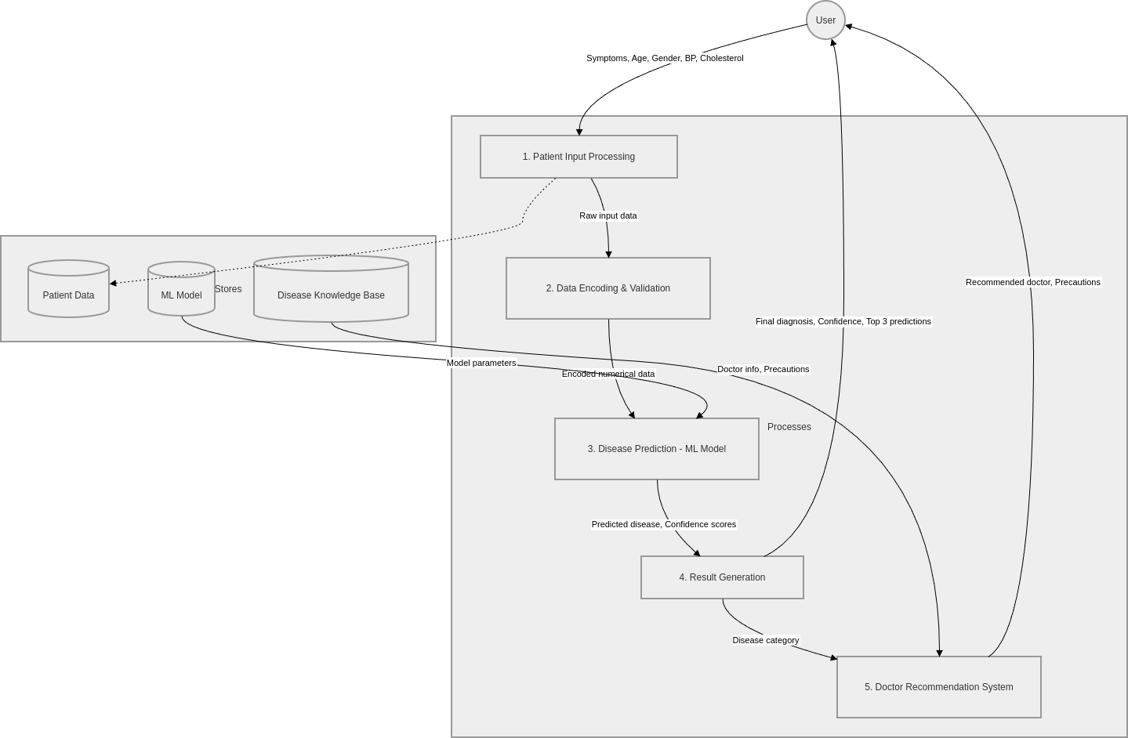

6. External Interface Requirements

6.1 User Interface
- The UI shall be implemented as a responsive web application accessible via a standard browser
- The symptom selection interface shall use toggle buttons or checkboxes for ease of interaction
- Health parameters (age, gender, BP, cholesterol) shall be entered via form inputs and dropdowns
- A dedicated result dashboard shall display prediction results, confidence scores, doctor recommendation, and precautions

6.2 Software Interface — REST API Specification

Property | Details
Endpoint | POST /predict
Content-Type | application/json
Authentication | None (current version)
Request Format | JSON object containing symptom flags and patient health parameters
Response Format | JSON object with predicted disease, confidence scores, doctor type, and precautions
Error Format | JSON with 'error' key and descriptive message; HTTP 4xx/5xx status codes

6.3 Communication Interface
- Frontend-to-backend communication shall use HTTP/HTTPS over standard web protocols
- Data shall be serialized and deserialized using the JSON format
- Cross-Origin Resource Sharing (CORS) shall be configured on the Flask backend to allow frontend requests

7. Assumptions and Constraints

7.1 Assumptions
- The training dataset used for the ML model is assumed to be representative of common diseases and their associated symptoms
- Users are assumed to provide accurate and truthful symptom information
- The deployment environment is assumed to support Python 3.8+ and Node.js 16+
- A stable internet connection is assumed for cloud-based deployment scenarios

7.2 Constraints
- The ML model's predictive accuracy is bounded by the size, quality, and coverage of the training dataset
- The system is not intended to replace professional medical diagnosis and must not be used as such
- Patient authentication and secure data storage are out of scope for the current version
- The system currently supports English language only

8. Future Enhancements

The following enhancements are identified for consideration in future development iterations:

Enhancement | Description | Priority
User Authentication | JWT-based login/registration system for patients and doctors | High
Patient History | Persistent storage of patient records and past diagnoses | High
Real-Time Consultation | Live chat or video consultation integration with verified doctors | Medium
Improved ML Accuracy | Retrain models with larger, validated medical datasets | High
Multilingual Support | Support for regional Indian languages (Hindi, Tamil, etc.) | Medium
Mobile Application | Native iOS and Android applications | Low
PDF Report Generation | Downloadable medical prediction reports for patients | Medium
EHR Integration | Integration with Electronic Health Record systems | Low

9. ER DIAGRAM

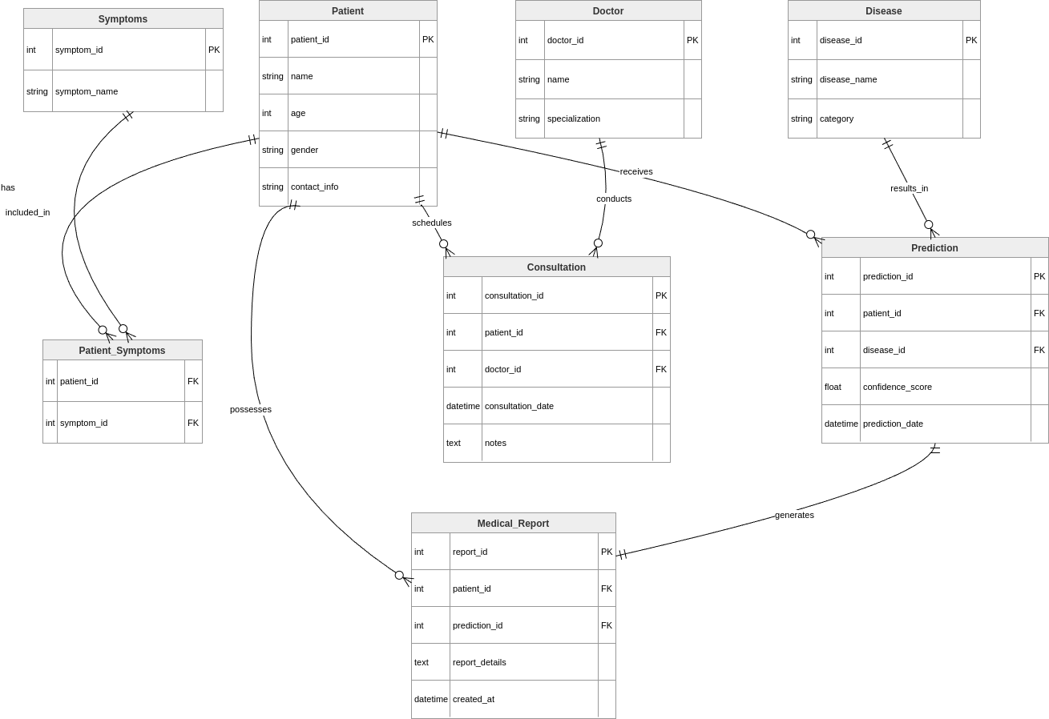

10. CLASS DIAGRAM

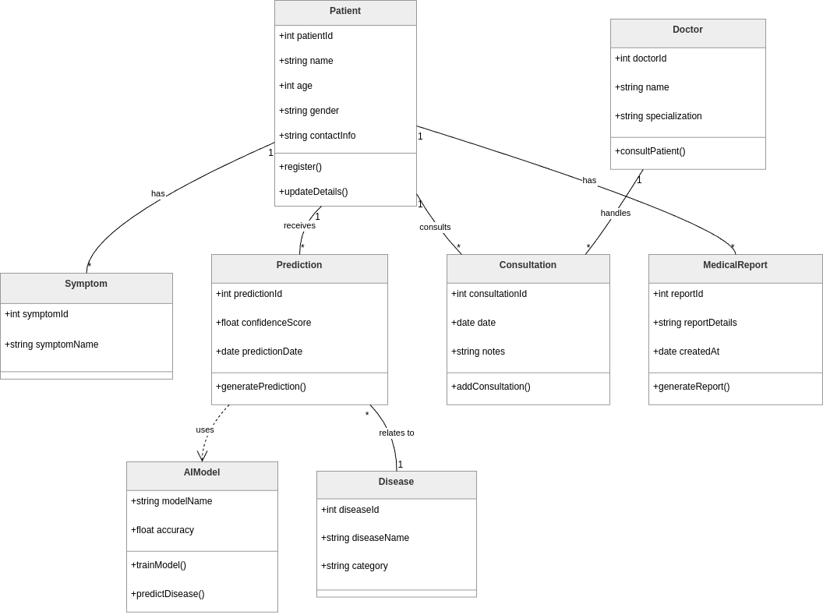

11. CODE (ML MODEL)
import re
from sklearn.model_selection import train_test_split
from sklearn.ensemble import RandomForestClassifier
from sklearn.preprocessing import LabelEncoder
from sklearn.metrics import accuracy_score
import pickle
import pandas as pd
df = pd.read_csv("Disease_symptom_and_patient_profile_dataset.csv")
def normalize(text):
text = str(text).lower().strip()
text = text.replace("&", " and ")
text = re.sub(r"[^a-z0-9]+", " ", text)
text = re.sub(r"\s+", " ", text).strip()
return text

def map_disease(raw):
d = normalize(raw)

if any(x in d for x in ["influenza","cold","dengue","hepatitis","malaria","rabies",
"chickenpox","tuberculosis","cholera","sepsis","ebola",
"zika","typhoid","measles","mumps","polio","infection",
"uti","hiv","aids"]):
return "Infectious"

elif any(x in d for x in ["asthma","bronch","pneumonia","copd",
"chronic obstructive pulmonary","sinus","tonsillitis"]):
return "Respiratory"

elif any(x in d for x in ["heart","hypertension","stroke","artery","atherosclerosis"]):
return "Cardiovascular"

elif any(x in d for x in ["epilepsy","parkinson","alzheimer","sclerosis","migraine"]):
return "Neurological"

elif any(x in d for x in ["depression","anxiety","bipolar","schizo",
"obsessive compulsive","ocd","autism"]):
return "Mental"

elif any(x in d for x in ["cancer","tumor","melanoma","lymphoma"]):
return "Cancer"

elif any(x in d for x in ["syndrome","cystic fibrosis","hemophilia"]):
return "Genetic"

elif any(x in d for x in ["diabetes","thyroid","pcos","hypoglycemia","hyperglycemia"]):
return "Metabolic"

elif any(x in d for x in ["colitis","gastro","liver","pancrea","append","digest"]):
return "Digestive"

else:
return "Other"

df["Disease_Category"] = df["Disease"].apply(map_disease)

df = df[df['Disease_Category'].map(df['Disease_Category'].value_counts()) >= 5]

df.drop("Outcome Variable", axis=1, inplace=True)
df.fillna(0, inplace=True)

df.replace({'Yes': 1, 'No': 0}, inplace=True)

df['Gender'] = LabelEncoder().fit_transform(df['Gender'])
df['Blood Pressure'] = LabelEncoder().fit_transform(df['Blood Pressure'])
df['Cholesterol Level'] = LabelEncoder().fit_transform(df['Cholesterol Level'])

le_target = LabelEncoder()
df['Disease_Category'] = le_target.fit_transform(df['Disease_Category'])

X = df[[
"Fever", "Cough", "Fatigue", "Difficulty Breathing",
"Age", "Blood Pressure", "Cholesterol Level", "Gender"
]]
y = df["Disease_Category"]

print("Class distribution:\n", y.value_counts())

X_train, X_test, y_train, y_test = train_test_split(
X, y, test_size=0.2, stratify=y, random_state=42
)

model = RandomForestClassifier(
n_estimators=300,
max_depth=12,
min_samples_split=5,
class_weight="balanced",
random_state=42
)
model.fit(X_train, y_train)
feature_importance = pd.Series(model.feature_importances_, index=X.columns)
print("\nFeature Importance:\n")
print(feature_importance.sort_values(ascending=False))
y_pred = model.predict(X_test)
accuracy = accuracy_score(y_test, y_pred)

print(f"Model Accuracy: {accuracy * 100:.2f}%")
probs = model.predict_proba(X_test)

pickle.dump(model, open("model.pkl", "wb"))
pickle.dump(le_target, open("label_encoder.pkl", "wb"))

print("Model saved successfully!")

CODE (BACKEND)

from flask import Flask, request, jsonify
from flask_cors import CORS
import pickle
import numpy as np

app = Flask(__name__)
CORS(app)

model = pickle.load(open("model.pkl", "rb"))
le = pickle.load(open("label_encoder.pkl", "rb"))
disease_info = {
"Respiratory": {
"doctor": "Pulmonologist",
"precautions": [
"Avoid dust, smoke, and allergens",
"Stay hydrated",
"Use a mask in polluted areas",
"Seek medical help if breathing worsens"
]
},
"Infectious": {
"doctor": "General Physician",
"precautions": [
"Maintain hygiene",
"Wash hands regularly",
"Avoid close contact with infected people",
"Take proper rest"
]
},
"Cardiovascular": {
"doctor": "Cardiologist",
"precautions": [
"Avoid fatty foods",
"Exercise regularly",
"Monitor blood pressure",
"Reduce stress"
]
},
"Neurological": {
"doctor": "Neurologist",
"precautions": [
"Get enough sleep",
"Avoid stress",
"Follow prescribed medications",
"Regular check-ups"
]
},
"Mental": {
"doctor": "Psychiatrist / Psychologist",
"precautions": [
"Practice mindfulness",
"Talk to someone you trust",
"Maintain routine",
"Seek professional help if needed"
]
},
"Cancer": {
"doctor": "Oncologist",
"precautions": [
"Early diagnosis is critical",
"Avoid smoking/alcohol",
"Regular screenings",
"Follow medical advice strictly"
]
},
"Metabolic": {
"doctor": "Endocrinologist",
"precautions": [
"Maintain healthy diet",
"Exercise regularly",
"Monitor blood sugar levels",
"Avoid excessive sugar intake"
]
},
"Digestive": {
"doctor": "Gastroenterologist",
"precautions": [
"Eat balanced diet",
"Avoid spicy/junk food",
"Stay hydrated",
"Maintain proper meal timings"
]
}
}

@app.route("/")
def home():
return "AI Healthcare Diagnosis API is running"

@app.route("/predict", methods=["POST"])
def predict():
data = request.json

try:
fever = data["Fever"]
cough = data["Cough"]
fatigue = data["Fatigue"]
breathing = data["Difficulty Breathing"]
age = data["Age"]
gender = data["Gender"]
bp = data["Blood Pressure"]
chol = data["Cholesterol Level"]

input_data = np.array([[fever, cough, fatigue, breathing, age, gender, bp, chol]])

prediction = model.predict(input_data)[0]
prediction_label = le.inverse_transform([prediction])[0]
info = disease_info.get(prediction_label, {
"doctor": "General Physician",
"precautions": ["Consult a doctor for proper diagnosis"]
})

probs = model.predict_proba(input_data)[0]
top3 = sorted(
list(zip(model.classes_, probs)),
key=lambda x: x[1],
reverse=True
)[:3]

return jsonify({
"prediction": prediction_label,
"doctor": info["doctor"],
"precautions": info["precautions"],
"top_3": [
{
"class": le.inverse_transform([c])[0],
"confidence": round(float(p), 2)
}
for c, p in top3
]
})

except Exception as e:
return jsonify({"error": str(e)})

if __name__ == "__main__":
app.run(debug=True)

from flask import Flask, request, jsonify
from flask_cors import CORS
import pickle
import numpy as np

app = Flask(__name__)
CORS(app)

model = pickle.load(open("model.pkl", "rb"))
le = pickle.load(open("label_encoder.pkl", "rb"))
disease_info = {
"Respiratory": {
"doctor": "Pulmonologist",
"precautions": [
"Avoid dust, smoke, and allergens",
"Stay hydrated",
"Use a mask in polluted areas",
"Seek medical help if breathing worsens"
]
},
"Infectious": {
"doctor": "General Physician",
"precautions": [
"Maintain hygiene",
"Wash hands regularly",
"Avoid close contact with infected people",
"Take proper rest"
]
},
"Cardiovascular": {
"doctor": "Cardiologist",
"precautions": [
"Avoid fatty foods",
"Exercise regularly",
"Monitor blood pressure",
"Reduce stress"
]
},
"Neurological": {
"doctor": "Neurologist",
"precautions": [
"Get enough sleep",
"Avoid stress",
"Follow prescribed medications",
"Regular check-ups"
]
},
"Mental": {
"doctor": "Psychiatrist / Psychologist",
"precautions": [
"Practice mindfulness",
"Talk to someone you trust",
"Maintain routine",
"Seek professional help if needed"
]
},
"Cancer": {
"doctor": "Oncologist",
"precautions": [
"Early diagnosis is critical",
"Avoid smoking/alcohol",
"Regular screenings",
"Follow medical advice strictly"
]
},
"Metabolic": {
"doctor": "Endocrinologist",
"precautions": [
"Maintain healthy diet",
"Exercise regularly",
"Monitor blood sugar levels",
"Avoid excessive sugar intake"
]
},
"Digestive": {
"doctor": "Gastroenterologist",
"precautions": [
"Eat balanced diet",
"Avoid spicy/junk food",
"Stay hydrated",
"Maintain proper meal timings"
]
}
}

@app.route("/")
def home():
return "AI Healthcare Diagnosis API is running"

@app.route("/predict", methods=["POST"])
def predict():
data = request.json

try:
fever = data["Fever"]
cough = data["Cough"]
fatigue = data["Fatigue"]
breathing = data["Difficulty Breathing"]
age = data["Age"]
gender = data["Gender"]
bp = data["Blood Pressure"]
chol = data["Cholesterol Level"]

input_data = np.array([[fever, cough, fatigue, breathing, age, gender, bp, chol]])

prediction = model.predict(input_data)[0]
prediction_label = le.inverse_transform([prediction])[0]
info = disease_info.get(prediction_label, {
"doctor": "General Physician",
"precautions": ["Consult a doctor for proper diagnosis"]
})

probs = model.predict_proba(input_data)[0]
top3 = sorted(
list(zip(model.classes_, probs)),
key=lambda x: x[1],
reverse=True
)[:3]

return jsonify({
"prediction": prediction_label,
"doctor": info["doctor"],
"precautions": info["precautions"],
"top_3": [
{
"class": le.inverse_transform([c])[0],
"confidence": round(float(p), 2)
}
for c, p in top3
]
})

except Exception as e:
return jsonify({"error": str(e)})

if __name__ == "__main__":
app.run(debug=True)

12. OUTPUT (LOCAL WEBSITE)
